|  |  |
| --- | --- |
| Microsoft Project (@project) | Twitter  Assignment 2- MS Project | Report on MS ProjecT    3º Course  Project Management |

Contenido

Part 1 2

Project Set-up 2

Salaries 3

Calendar 3

Critical Path 4

Other statistics 4

Part 2 6

# Part 1

## Project Set-up

As obvious as it may sound, the first step it to build the project, given some tasks, resources (in this case, as for personnel), workload and relations among each task (it is not going to be shown the whole table, as it seems irrelevant for the whole understanding of the actions taken).

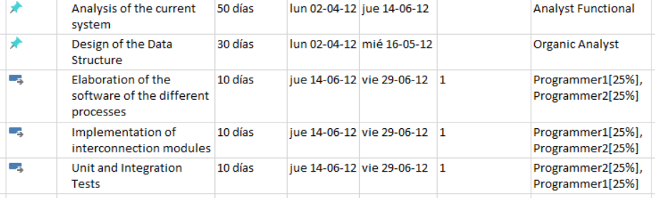

After having included all the entries in the table given by the professor, the result is the following (including a periodic task, although not all its iterations are shown in the screenshot):

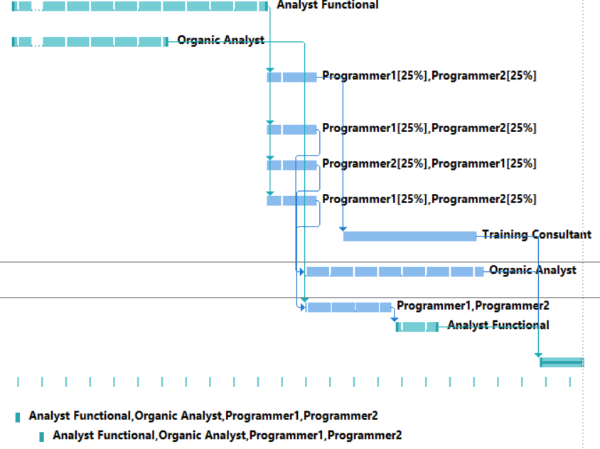

## Salaries

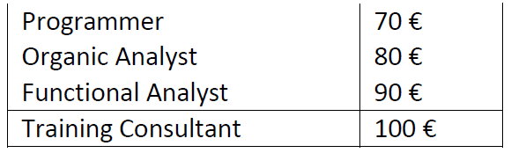Each worker has their own salary, depending on their position:

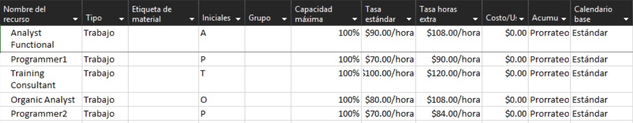Inserting the values, to MS Project it is given the following specification:

## Calendar

The company has the following holydays programmed:

* 8th and 9th of April 2012.
* On Friday in July it will only be worked in the morning.
* August there will be vacations.

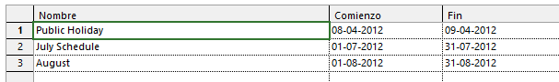

Also, the programmer 2, has the following holydays:

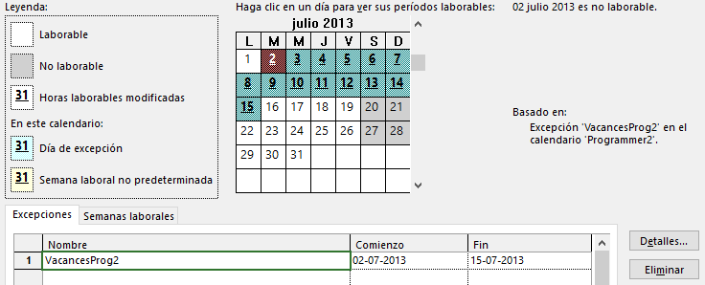

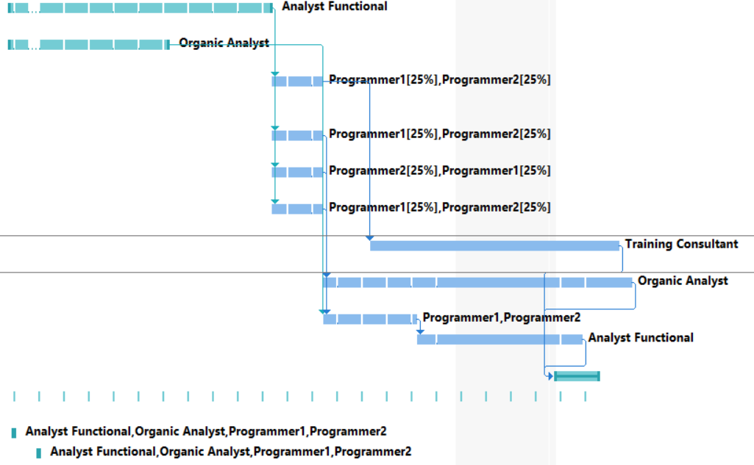The Gantt Chart is left as follows:

## Critical Path

The development of the project leads to the unavoidable truth that there exist two critical paths (according to MS Project functionalities) within the schedule.

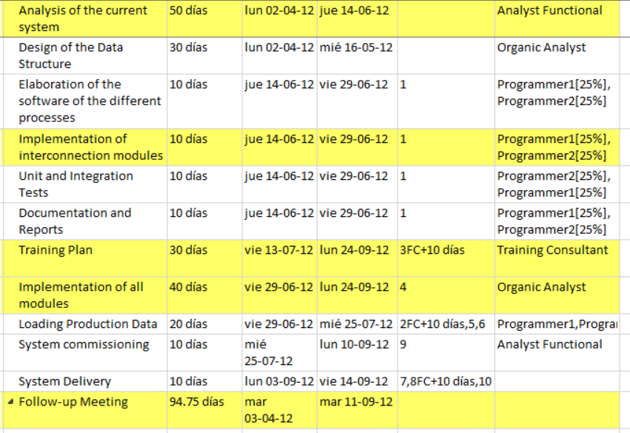

## Other statistics

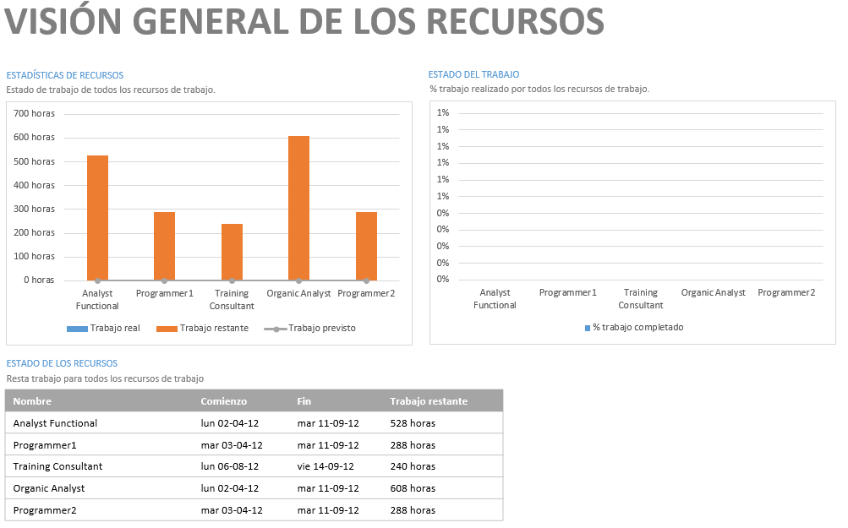The examiner has also asked for some other statistics, but in order not to make this file too long, here there are those statistics:

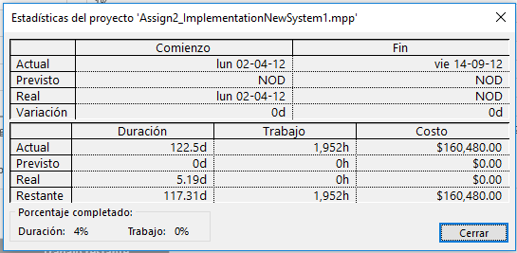

And last, but not least, the selection of the day for trainer to perform his activity:

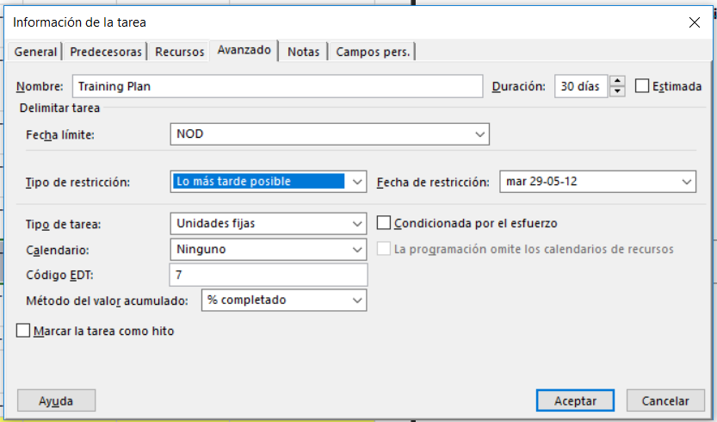

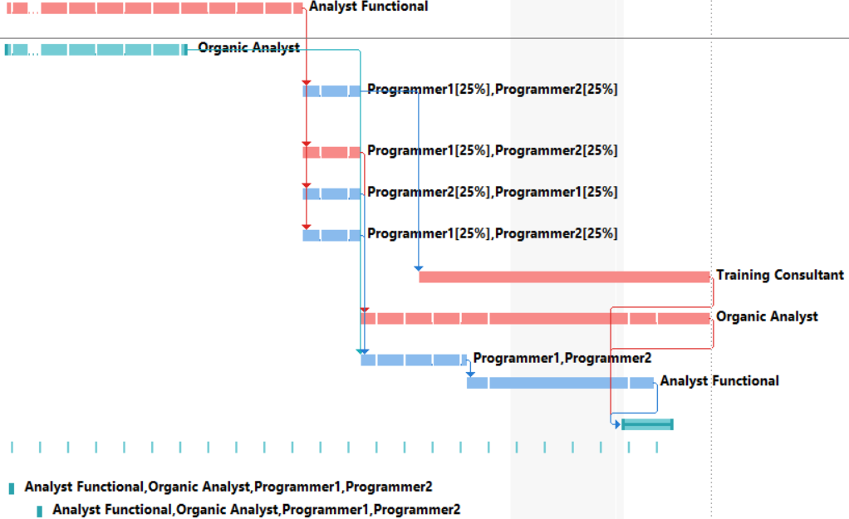

# Part 2

1. Setting up the project.

First, the data from the given table is introduced into the program and completed its columns with the values from the problem. The beginning and ending dates are created based on the day of creation of the project.

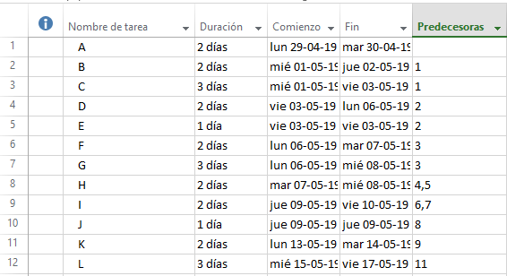

1. Network diagram.

To create the network diagram, the “diagrama de red” is selected from the options.

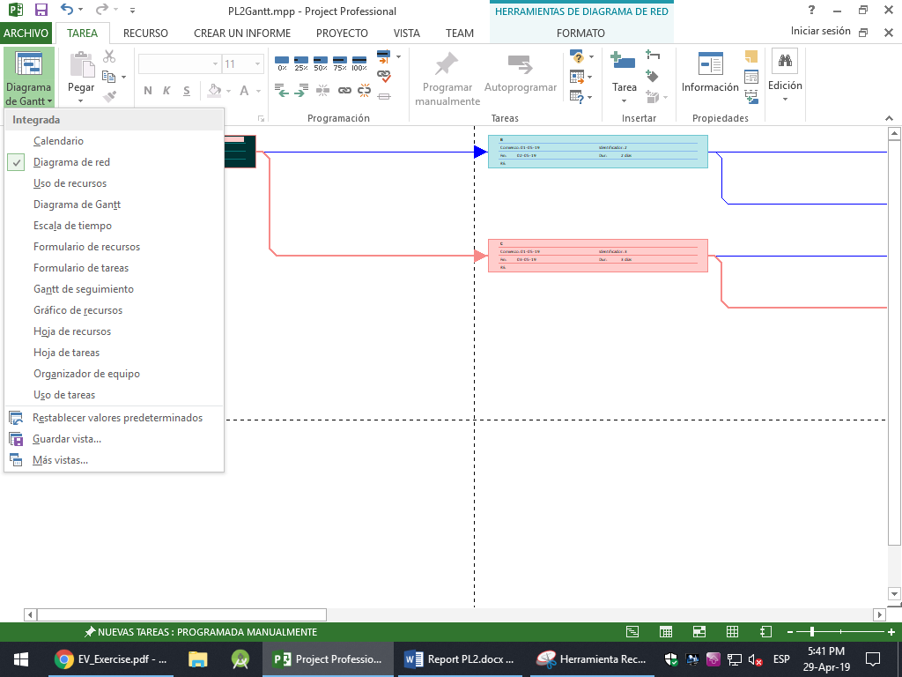

Then, based on the data previously introduced, a full column is selected and the diagram is created automatically. The full network diagram is as follows.

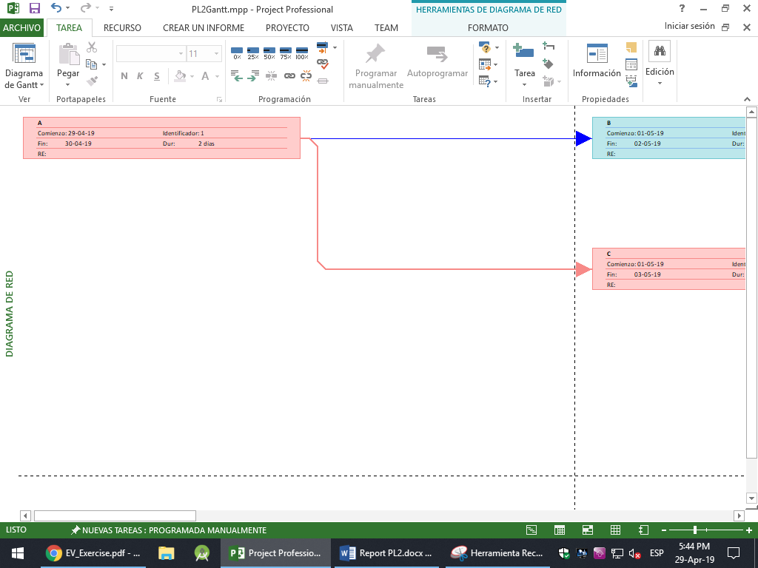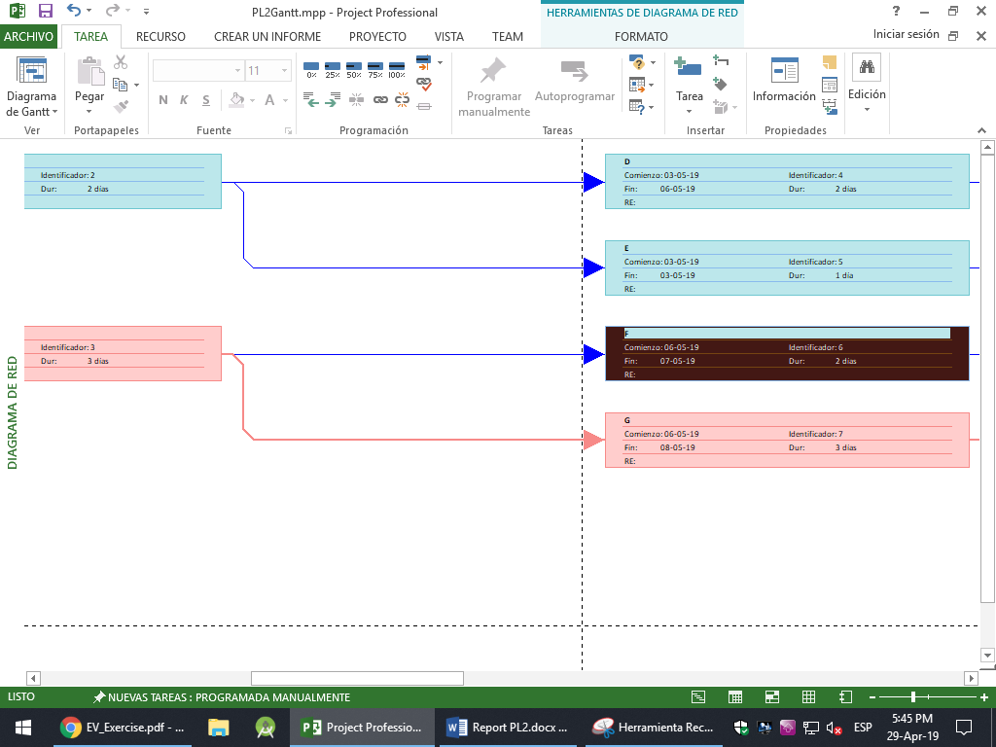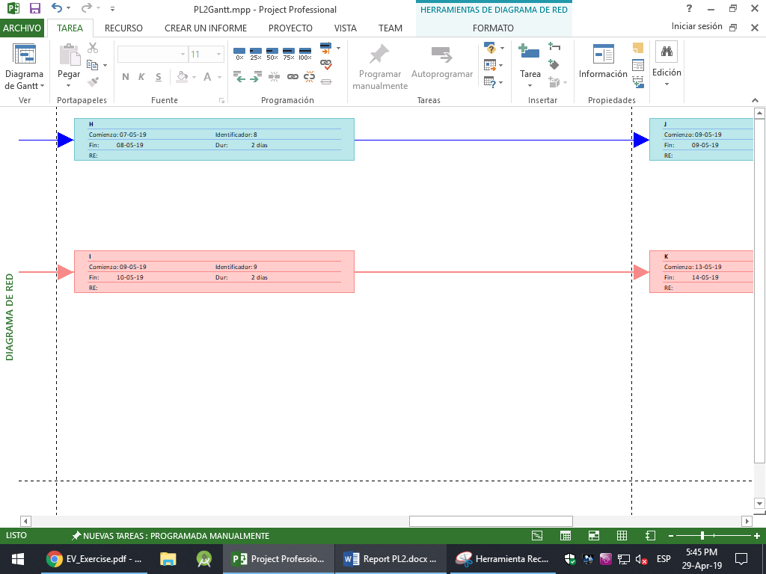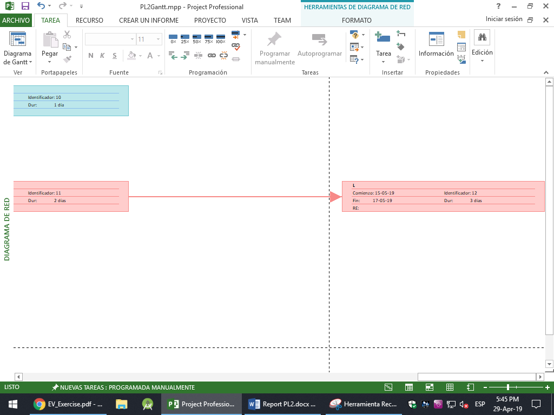

In this diagram, the pink cells represent the critical path, that is, the tasks that will make the project slower, while the blue cells represent tasks that are not in the critical path and do not delay nor slow down the project.

1. Project duration and critical path.

MS Project creates a timeline based on the duration of each task and the beginning date. To view this duration graphically, the option “escala de tiempo” must be selected, and the representation appears next.

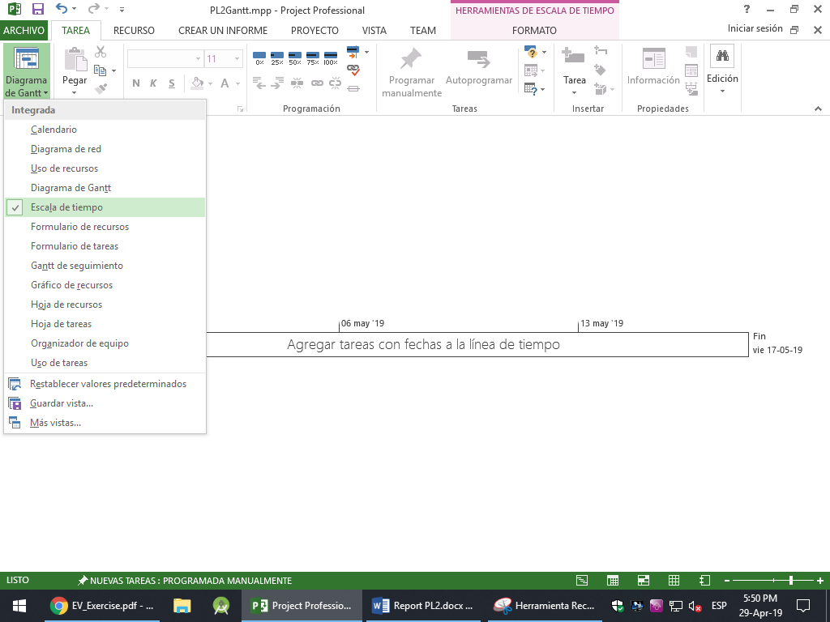

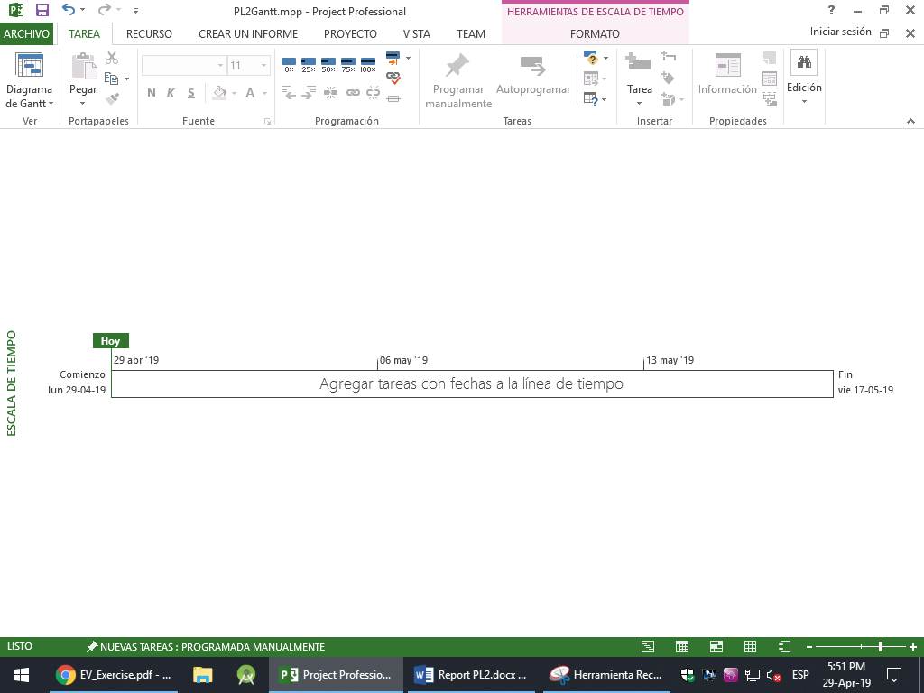

1. Gantt chart.

As previous sections, the Gantt chart is selected in the contextual menu.

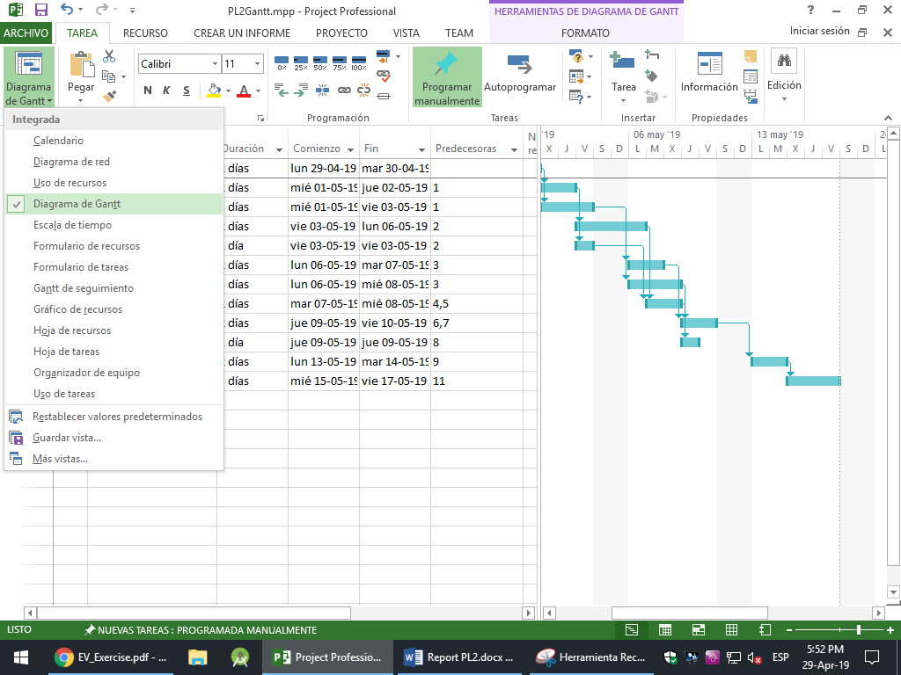

Next, the diagram based on the introduced data is created automatically in the right side of the screen.

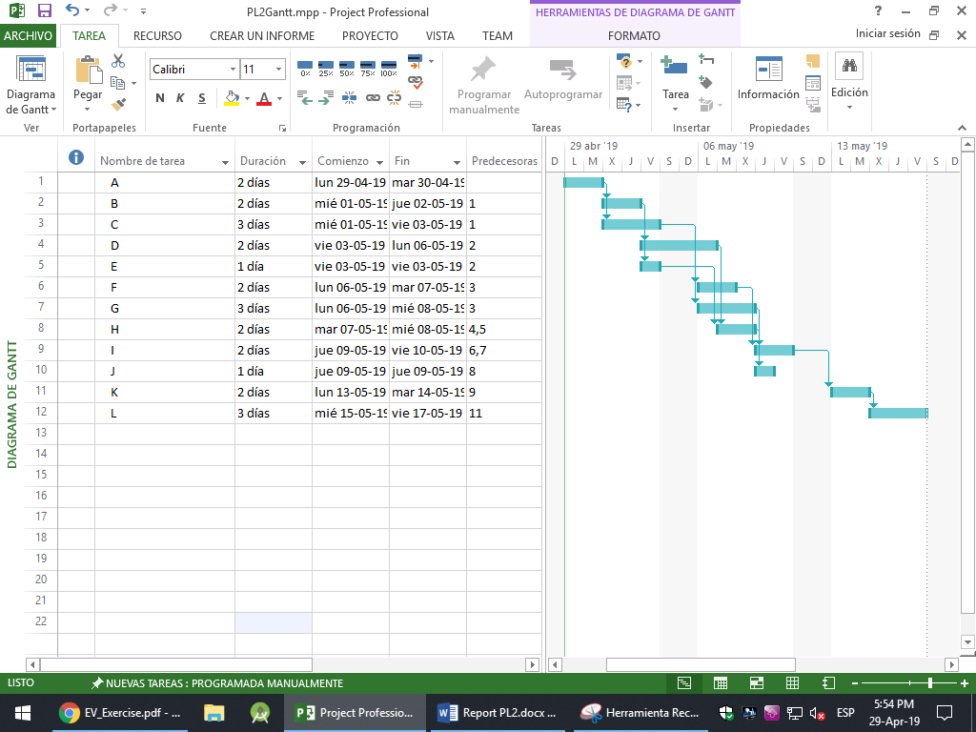

Moreover, MS Project comes with an option to create a following Gantt chart, which tracks the completed percentage of each task, and can be selected this way.

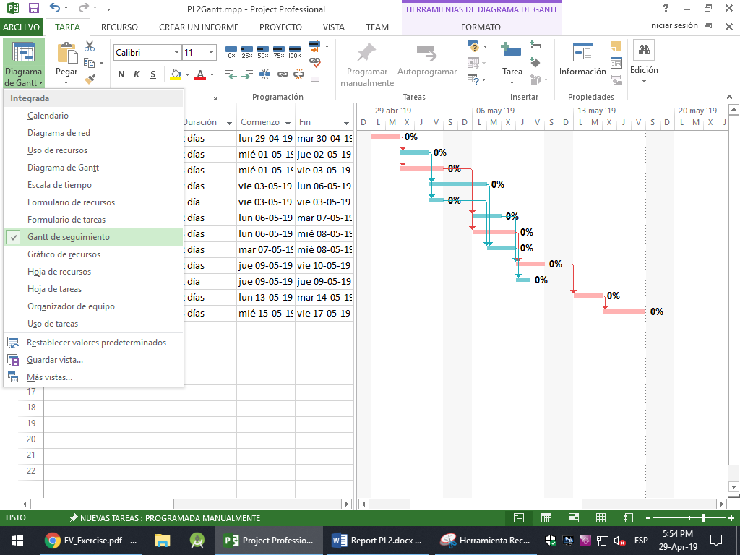

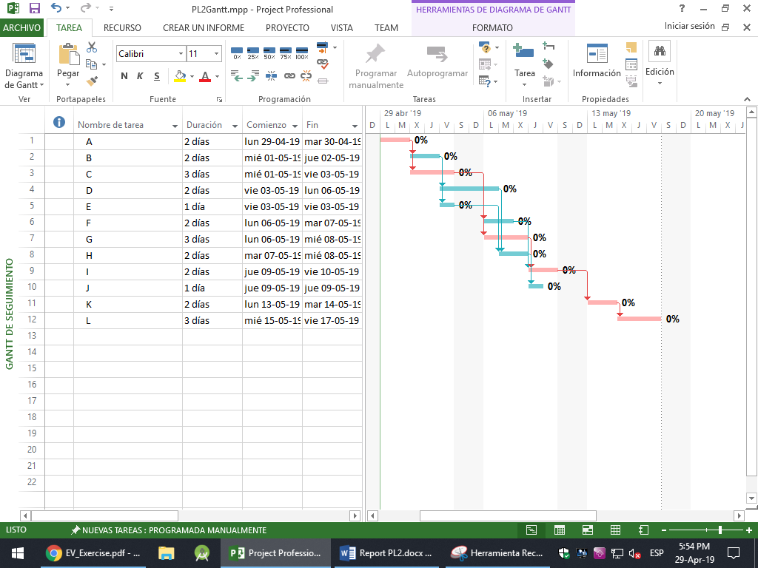

1. Earned Value.

First, the resources and task costs are introduced manually. Then, manually, each task is assigned to each resource following the given data. If the data is introduced as the problem states, each worker will have more hours than allowed, so it is needed to reassign each task and postpone some tasks for later. This is done automatically, and the results are these.

